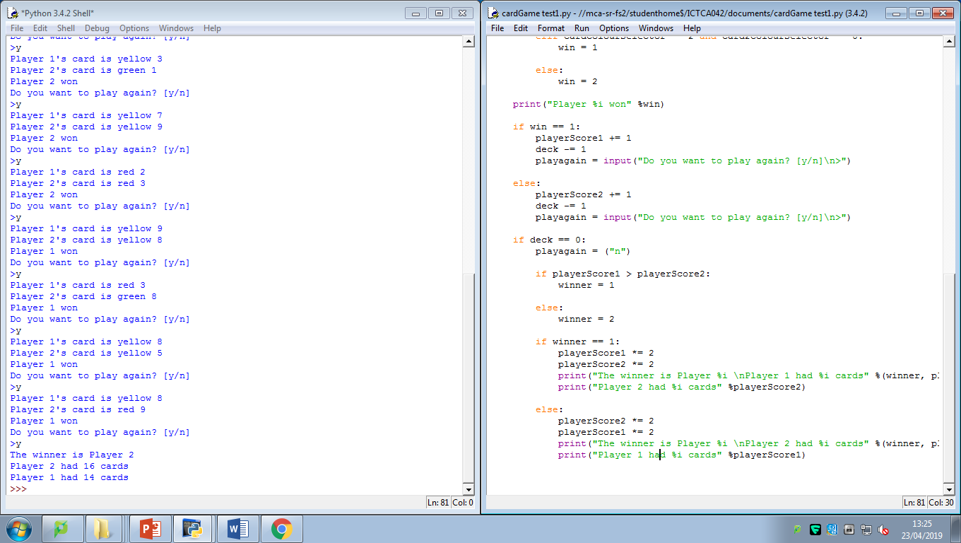

23/04/19 13:25

I have now finished the main block of code, all that is left to implement is the account and high-score system and the pickling of that to a file.